**OUTPUT:**

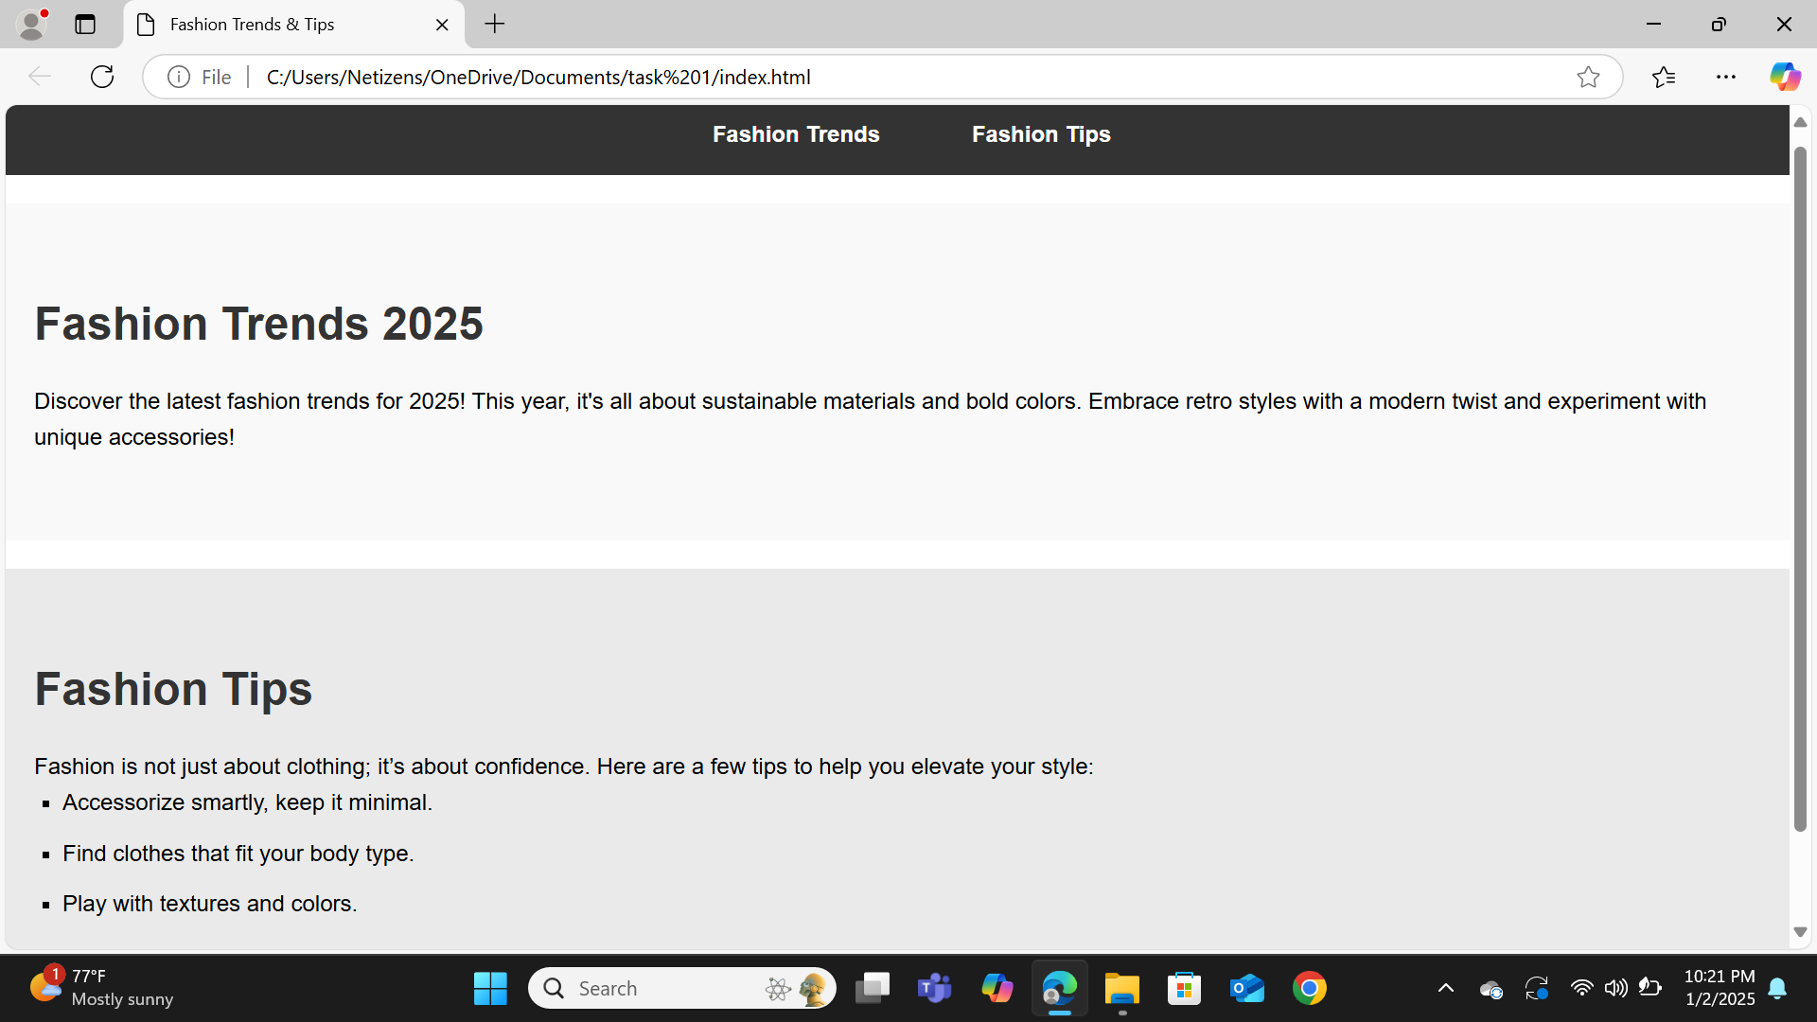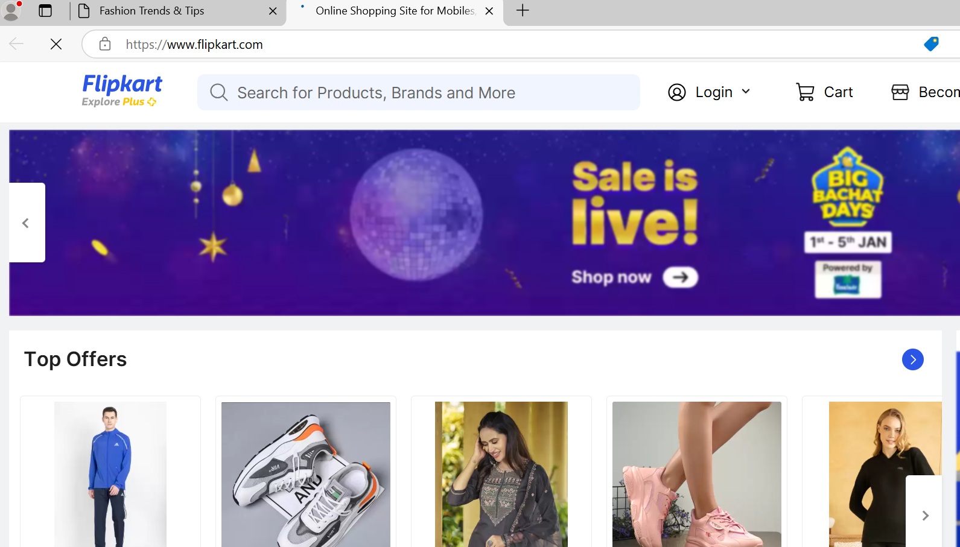

**When you click on the fashionTrends then it will display flipkart page** :